Hi Sunny –

The most recent chart is fantastic – thanks so much for putting it together! And the addition of Sharpe Ratio is looking great too.

This next chart will be a little different… I would like to add a table to the website (as opposed to a chart from amcharts). I currently have one on the existing site here: <https://williamgorfein.com/Durability.html>

The table that I think will be ideal is this one: <https://www.zinggrid.com/demos/website-visitors>

Zing Grid has many good table templates and many are simple too. I think this one combines simplicity with good design.

The information the table should display will come from our postgres database… but I had some difficulty creating the new table and uploading the information. Do you mind creating code to add to the CRUD_ops class that can handle the upload of a dataframe that’s in the same format as the one shown in the attached Jupyter notebook? I had difficulty with the column formats – more specifically columns containing strings and NaN values. (one column is intended to be all NaN except for one single row)

There is one custom feature I’m hoping to be able to incorporate… do you mind checking if it is possible to highlight one single row? The row I’m hoping to have highlighted is the single one containing the value in the KDE Score column. I have included a screenshot below I made in MS Paint to demonstrate:

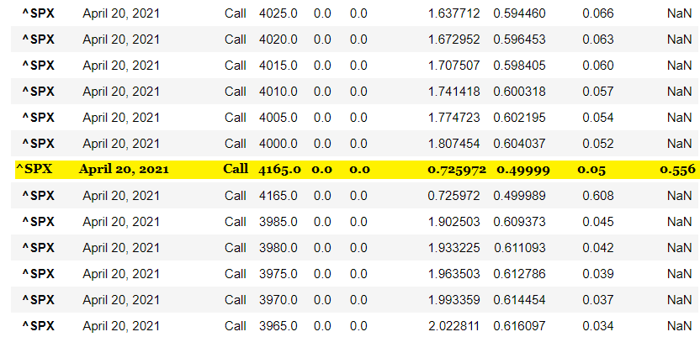

I believe it’s possible using their conditional formatting feature: https://www.zinggrid.com/docs/features/conditional-formatting